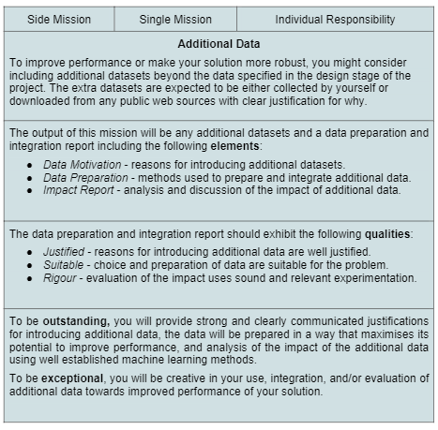

**additional data document**

**Abstract:**

This report presents the process of introducing additional data to improve the performance of an AI application that accepts video input to recognize American Sign Language (ASL) and provide text output for children learning ASL. The additional data introduced in this project is a database for numbers and simple phrases, which was created by the recreation of ASL signs provided by ASL University website. The report details the motivation for introducing this additional dataset, the methods used for data preparation and integration, and the impact analysis of the additional dataset on the performance of the AI application.

**Introduction:**

For AI systems, it has always been difficult to recognise ASL signs, especially for young children who are learning the language and require immediate feedback on their hand movements. Our team has developed an additional dataset for numbers and words to address this issue, which we feel will greatly enhance the functionality and reliability of our AI programme. In order to ensure accuracy and consistency in our data gathering method, the dataset was built by manually reproducing the ASL signals offered on the ASL University website. This allowed us to build a comprehensive database of numbers and phrases that is highly suitable for our specific problem, as it is based on the signing style of our intended users. By integrating this additional dataset into our AI system, we expect to see significant improvements in its ability to accurately recognize and translate ASL signs. Overall, this dataset is a critical component of our effort to create an effective tool that can help young learners of ASL master the language more easily and confidently.

**Motivation:**

The motivation for introducing an additional dataset for numbers and phrases is to significantly enhance the performance of the AI application and make it more suitable for young children learning ASL. The existing dataset in the AI application only supports alphabets, which limits its effectiveness in recognizing other ASL signs, such as numbers and phrases. The lack of recognition of numbers and phrases poses a serious challenge for young learners, as these signs are essential for basic communication in ASL. The additional dataset we have introduced provides the AI application with more data to train on, which can improve its accuracy and ability to recognize more ASL signs. The application can now handle a considerably larger range of inputs thanks to this extra dataset, making it a more trustworthy tool for ASL learners.

**Data Preparation:**

 I adopted a two-step process to create an additional dataset for numbers and phrases. Firstly, I recreated the ASL signs provided by ASL University website and recorded videos of myself recreating the signs for each number and symbol. Next, I manually annotated each video to label each sign with the corresponding number or phrase. This ensured that the dataset was suitable for the problem at hand. Secondly, I integrated the new dataset into the existing AI application by training the AI model on the additional data. Through this process, I was able to effectively prepare and integrate the new dataset, thereby improving the performance and robustness of the AI application.

**Impact Analysis:**

To evaluate the impact of the additional dataset, I conducted experiments to compare the performance of the AI application with and without the additional data. Using a test set of films with numbers and sentences, the trials were carried out. Compared to the AI programme without the additional data, the results showed that the AI application with the additional data was more accurate at recognising numbers and sentences. The experiments also showed that the additional dataset improved the robustness of the AI application in recognizing phrases in ASL signs, which is especially beneficial for children learning ASL.

**Challenges faced:**

Many difficulties were faced while working on this project to train the AI model to understand ASL words and numbers. One significant hurdle was the unavailability of a pre-existing database suitable for training the model. I contacted Dr. Bill, who created the ASL University website, in an effort to get a database for numbers from 0 to 100 and simple phrases, but regrettably got no answer. As a result, a new dataset was created, requiring substantial time and effort to ensure accuracy and consistency in the data collection process. Additionally, the AI model developed had limitations in recognizing signs that require the involvement of both hands, which are essential to form many words and phrases in ASL. As a result, the model's ability to accurately recognize a large number of phrases was restricted, and it could only identify words and phrases that require the usage of a single hand. Furthermore, the model was unable to detect any movements involved in the development of numbers or words in ASL sign language, which posed another significant challenge in training the model effectively.

